1_67 version changes!!! page 3

In Dropbox we have a folder called www_spiritchannel
There we have the backbone of the webpage, the text files, that is used by the program to generate the webpage. The folder named t is where we save all the transcripts. All transcripts are saved by using this format
yyyy-mm-dd.html. You can also use yyyy-mm-dd.html.txt but the program will rename it to .html as you start the program the first time.
The reason for using a date format is that the program needs to match the right transcript to the right audio when generating the webpage; it then gives that white/gray icon on the webpage.

2013 files belong together as a group and that 2012 belongs to another group etc.

Currently the files in one group is as in the below example
2013header.txt = contains a menu, the search box and the red event button
2013footer.txt = the ending of the page. For 2013 it contains the disclaimer, counter, and flags map thing.
We rarely change the above 2 files (every New Year we have to add in a menu for the new year + change the date in the copyright to current year)

2013Audio_URL.txt = contains all audio Egnyte links for the entire year.
2013CallNames.txt =contains the headlines and/or questions for a call.
Every entry in these two files start with yyyy-mm-dd__and some text.
It is very important that we don’t use line breaks as each line is one call/session. These two files are matched together using the date. We can have any order of the dates (it does not matter). Each entry/date are loaded by the program and sorted in ascending order.

I usually use notepad to edit all txt files above.

To simplify things (to avoiding writing html code) we have a little special format going on in the 2013CallNames.txt.

example 1
2013-01-02__{text written here will be in white__text here will be in yellow and on a new line__and here in yellow too on a new line__and so on.

As you can see the left bracket ( { ) starts the line. That tells the program to make the first text in in white and then when it finds the first double underscore __ it then makes a line break and put that text into yellow
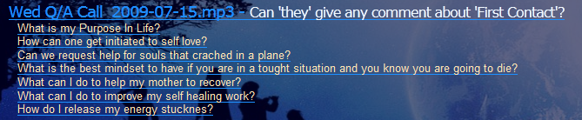

example 2
2013-01-02__{__text written here will be in yellow on a new line__text here will be in yellow too on a new line__and so on.

Here we have left bracket followed by double underscore {__
By doing so the program skips to write in white and makes a line break and starts to write in yellow.
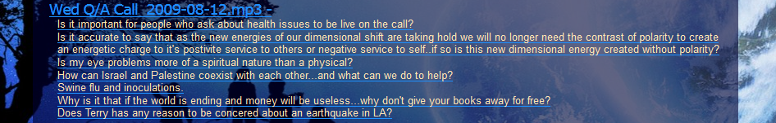

example 3
2013-01-02__text written here will be in blue__text here will be in blue too __and so on.

The above shows what happens when we skip the left bracket {

* Note that we NEVER should use} (close bracket/right bracket) at the end of a line

We can also use html code if needed in the 2013CallNames.txt file, if we want something special.

As you can see we never have to write the names of the audio name. It uses some default’s…the 3 most common defaults are;

Wed Q/A yyyy-mm-dd.mp3
Mon BBS Call_yyyy-mm-dd.mp3
Sun_Gridhealing_yyyy-mm-dd.mp3

We are not limited… we can have calls on the other days of the week too.
The program supports that.

So what to do if we want to change a default mp3 name for a call on a special date?

We can write like this

example 4
2013-01-02__[Healing call.mp3]Special healing call

The filename.mp3 inside the left and right bracket does the trick in the 2013CallNames.txt

The following should also be possible to do

example 5
2013-01-02__[Workshop call.mp3]{text will be white here__and yellow here

It is also possible to change default transcript icon for a call(currently only supports .png files). The images one can use are inside the images folder

example 6
2013-01-02__[mstar.png]{text will be white here__and yellow here

Combinations are also possible
2013-01-02__[Workshop call.mp3] [mstar.png]{text here as usual
Starting the program for the first time.
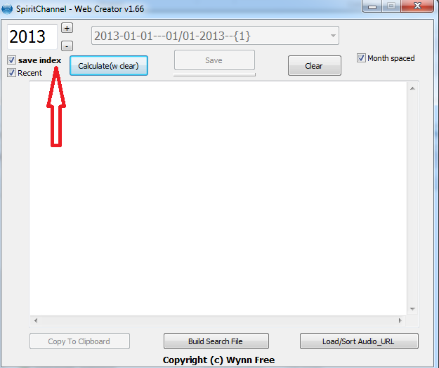

The save index checkbox and Recent checkbox should always and only be used for the current year we are in (2013).

Save index (checked) =is the start page we want people to come to as they enter www.spritchannel.net
The most logical thing is that they are interested in the newest calls so that is why we use current year. The file name will be index.html (when you click save) instead of the year (2013.html) displayed in the left upper box

Recent (checked)
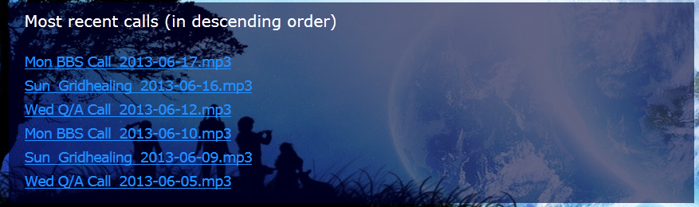
Makes the following box appear on the upper area of the page (6 latest recorded calls) for the year that are displayed in upper left (2013)
So what happens when you click on Calculate button(if year 2013)?

- The program checks what checkboxes are active and generate the page from that.

- Loads 2013header.txt

- Loads 2013Audio_URL.txt + 2013CallNames.txt and match dates + search the t folder for transcripts

- Loads 2013footer.txt

- Lights up the save button. Red if index box is checked and green if not. (The reason for red is that one should pay attention for what year you are on when the index box is checked…before saving)

You can now save if you want too.

If the index box is NOT checked the filename will be yyyy.html
(…and index.html if checked)

We then upload index.html or 2012.html or other year to the website (using FTP or other method).

(If there has been new transcripts added in the t folder in dropbox we upload them to the same t folder on the webpage too).

The files and folders in dropbox is a mirror so it should be uploaded to the website when we have added transcripts etc.

We can look at changes before we upload them to the internet by just opening index.html into our browser (from dropbox folder www_spritichannel). The only thing that will fail is the red event button when running the website in this way (because of security reason in our most modern browsers…that does not allow things to run locally on our computer )

In the upper left corner we see the year. The program always grabs the year from your computer and puts it there. Plus and minus button changes year. You can also type in this field by hand (only accepts numbers).

Hack mode / series mode
If a year starts with 0yyy (in this example 0000) then program does things a little bit different for that file.

It still needs the files 0000 header and 0000footer files.

When you click calculate it works in the same way except for the following

- 0yyyCallnames.txt is supporting a new symbol [ .This symbol is telling the program to make a white headline and a transparent box. In normal mode this headline is usually January/February etc, but we now have the option to create this to our own liking.
- The program loads 0yyyAudio_URL.txt (if it exists, it don’t have too). It then loads every Audio_URL.txt that it can find. The reason for this is that hack/series mode is to highlight existing calls, so we usually have the audio link already to a call in another Audio_URL file…unless we want to add something new here (or force a different link for some reason).

If there is links inside 0000Audio_URL they are used first…then if not, the program searches the other files (yyyyAudio_URL.txt).
The links that the program is searching for is in the

So here is an example of a 0000CallNames.txt file

[How the Elohim Created the Universe
2009-12-14__Wynn and Terry and our channelled Source discuss how the Elohim created this realm
2009-12-28__{How did the Elohim Create the Universe?__The experiment of blending frequencies galaxies.
2010-01-04__How the Elohim Created this Realm.
2010-02-08__This is our continuing dialog on how the Elohim created this Realm
2010-02-22__This is part of a series of .."How the Elohim created the universe."
2010-03-01__The Creation of the Universe continued
2012-11-19__How the Elohim Created the Universe - continued
2012-11-26__How the Elohim Created the Universe - continued
2013-06-03__How the Elohim Created the Universe - continued
2013-06-10__How the Elohim Created the Universe - continued
2013-06-17__How the Elohim Created the Universe - continued

[Some text here that creates a second headline in a new transparent box.
yyyy-mm-dd__ {text here in white__this in yellow__and so on.

[Another headline if needed…you get the idea.

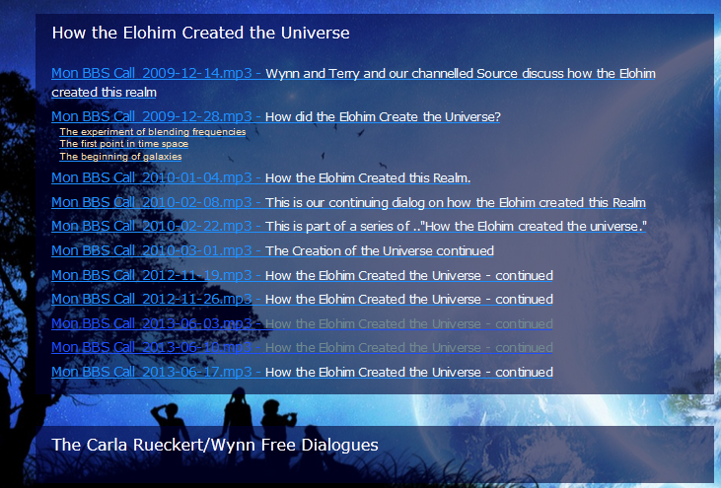
example below

